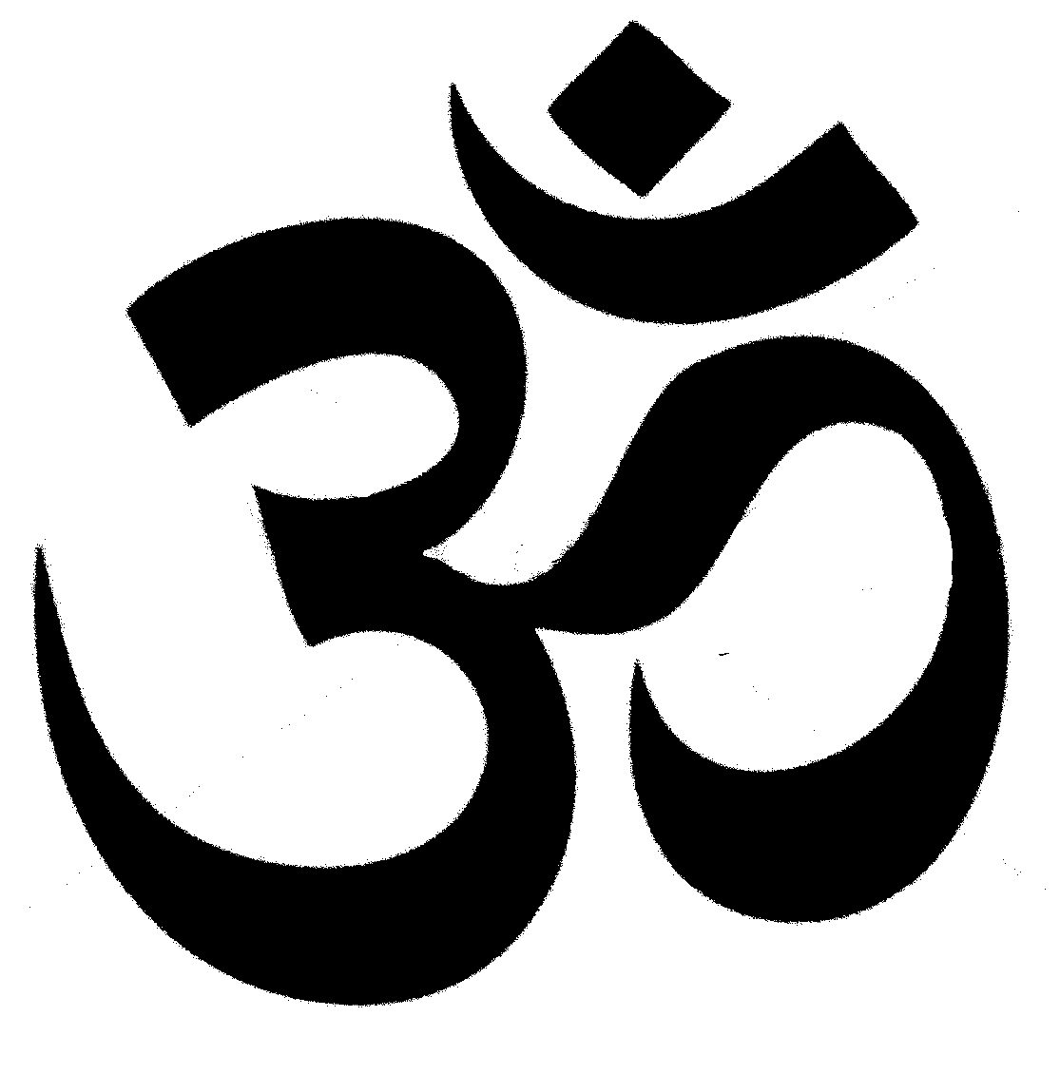
OM

Hinduism

Some questions answered

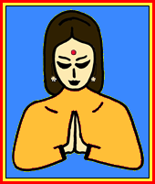

Hindus believe all religions are equal, but they are different paths to God. ‘As different streams with sources in different places all mingle their water in the sea, so O Lord, the different paths which humans take…all lead to Thee.’

These are some of the frequently asked questions from friends of other faiths.

These answers are the personal views of Ganesh Lall.
They are open to other interpretations because
the Hindu community worldwide is very diverse
and has differences in belief and practice.

Who is the founder of Hinduism?
- It does not have a founder.

Q. What are its roots?
A. It is a revealed religion. But the revelation is internal. It is the result of the questionings, experiences and collective wisdom of sages and saints over the ages.

Q. Was the name revealed?
A. No. The name ‘Hinduism’ is a Western construct which has become accepted by Hindus as well as non-Hindus.

Q. Why was Hinduism not given a name in the very beginning?
A. Because ‘religion’ is not an isolated concept in Indian culture. It permeates all life. Hindu culture is inclusive. We respect all faiths. This is the reason why a Hindu would never ask ‘what is your religion?’ It is considered impolite.
The purpose of naming is to distinguish between things that are similar, in this case, religions. In the beginning there was no
need to distinguish Hinduism because it was the only faith at the time, being the oldest religion.

3

Q. Do you have a prophet?
A. No. But we do have incarnations of God such as Rama and Krishna. And, we have great teachers, from time to time.

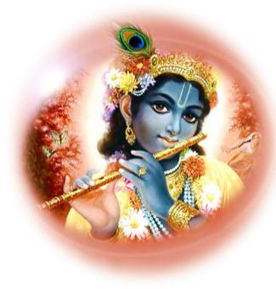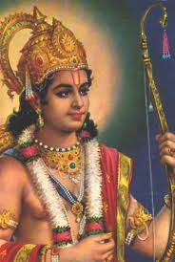

Lord Krishna Lord Rama

Q. Do you have a head such as the Pope or Archbishop of Canterbury?
A. No. Hinduism is a family of religious traditions, each with a different doctrinal emphasis. And each of these has a head. But, like members of a family, they share certain common beliefs, practices and values. And they live peacefully and in harmony.
Charismatic individuals arise from time to time to update beliefs and practises to make them relevant. The Hare Krishna movement emphasises Bhakti - Love of God aspect of religion; Mahatma Gandhi -non violence – ‘Ahimsa Parmo Dharmo’ Non Violence – The Supreme Duty in life.

4

Over the centuries, many highly regarded for their teachings include Adi Shankarcharaya, Paramhansa Ramakrishna, Maharishi Raman, Swami Vivekananda and Swami Dayanand.
Swami Vivekananda in his celebrated address at the Parliament of Religions in Chicago USA, in 1893 opened a window to America and the world to the core values of Hinduism. He declared that Hinduism itself was a parliament of religions and held in equal esteem different religions as different paths to God. He quoted an ancient hymn ‘As the different streams having their sources in different places all mingle their water in the sea, so O Lord, the different paths which men take through different tendencies…all lead to Thee.’
Swami Dayananda’s teachings were: equality, women to be treated equally, education, and denouncing of caste system.
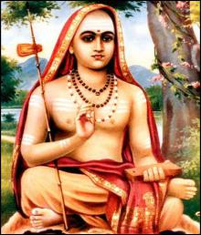

Adi Shankaracharya
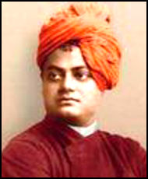
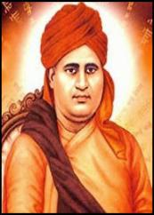
Figure 2Swami Dayananda

Adi Shankaracharya

Swami Dayananda
Swami Vivekananda

Q. What are your commandments?
A. We don’t have any. But we do have rules of righteous conduct (dharma). We do not have a common creed.

Q. What is dharma?
A. It is conduct that upholds harmony and truth.
5

Q. What is your holy book?
A. We have several but no one enjoys primacy over the others. Three of the most important are the Vedas, Ramayana and the Bhagavadgita.

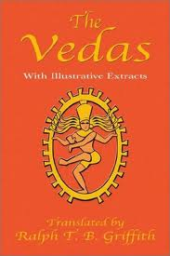
The Vedas

Q. What is your place of pilgrimage?
A. We have many, such as Varanasi, Hardwar and Rishikesh, and they are all visited by millions every year.

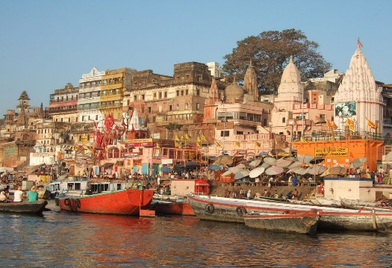

Varanasi
6

Q. How many times a day do you pray?
A. We don’t have set times or place. We pray anytime, anywhere, whether it be at home or in a temple, and we often call in to a temple as we pass by to offer devotions.

Q. Why do you have so many Gods.
A. We have only one God (Brahman), but many manifestations of the divine, with many names such as Prabhu, Bhagwan, and Ishwar. We see God in all things and all things in God.

Q. Why do your gods, have so many heads, eyes, and hands?
A.. The divine, being infinite, cannot be limited in either name or form. The heads, eyes and hands are symbolic representations of omniscience, omnipresence and
omnipotence, respectively.

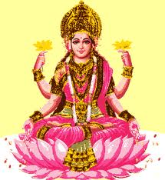
Lakshmi

7

Q. Why do you pray to idols?
A. We do not have idols. We have images
(murtis) of different aspects of God. We pray before them, not to them. They help us to focus our attentions on God. The icons of the early Christian church do the same thing. Other faiths have angels; we have devas and devis.

Q. Do you have to be born a Hindu?
A. No.

Q. How can a non-Hindu become a Hindu?
A. The simple answer is that you identify with the cultural and social values of Hinduism. We do not have a formal ceremony of admission like the Christian baptism. This stems from the fact that Hindus do not wish to proselytise. We think that it undermines mutual respect and causes disharmony.
Hindus believe that all religions are equal and it makes no sense to convert from one to another. This comes from a deep respect we have for all religions. Gandhi says if a man reaches the heart of his own religion he reaches the heart of all others. Truth is one but scholars call it by different names.

Q. Why do you worship the cow?
A. We do not. We have great reverence for the cow because it is so useful. It provides food in the form of milk, household fuel, fertiliser and help in ploughing the field. Reverence for the cow is deeply embedded in the Hindu psyche. Its slaughter is therefore abhorrent in India. Imagine the public outrage in this country if cats and dogs are slaughtered for the table!
8

Q. Why do you sit on the floor in the temple?
A. It is a mark of humility in the house of God.

Q. Why do you have so many forms of greeting?
A. India is a vast sub-continent with many cultures. It is much like Europe with France, Germany, etc., having their own forms of greeting.

Q. What is the caste system?
A. It is a social system dating back to centuries. It started as a functional division of labour but in practice it now discriminates against people on the basis of birth. Throughout the ages, social reformers and religious leaders such as the Buddha, Mahavir, Guru Nanak, Swami Dayanand, Swami Vivekanada, Gandhiji and Dr Ambedhkar, among others, have fought against this system of discrimination. It is an ugly scar across the face of India, and it is outlawed by the constitution of India.

Q. What is a pandit?
A. It is a title given to an educated person who is not necessarily a priest. Two well known pandits not associated with the priesthood, for instance, are Ravi Shankar (musician) and the late Jawaharlal Nehru (politician).

Q. What is a Guru?
A. In its Hindu meaning a Guru is a venerable spiritual teacher whose authority is highly respected.

9

Q. Are all Hindus vegetarians?
A. No. Vegetarianism is an offshoot of Buddhism and Jainism which teach that non-violence (ahimsa) is the greatest duty.

Lord Buddha

Q. What is OM?
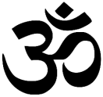
A. It is the first sound of creation, made up of the sounds of A, U and M, pronounced AUM. It is a sacred sound. All our prayers begin with OM.
Its symbol represents 4 states of consciousness: waking, dreaming, deep sleep and the fourth state, bliss- represented by the small dot on the top right hand side. Hindus believe that the ultimate goal of life is to attain to the fourth state. In this state we are at one with God, who dwells within our hearts as the divine self or Atman, pure and infinite bliss.

10

Q. What is Shanti?
A. It means peace. All our devotions end by chanting Shanti three times, wishing peace in the three worlds, (earth, heaven, and the lower regions) and for all living beings.

Q. What is the Hindu view of reincarnation?
A. Everything in the world is governed by the cyclical law of nature. The Sun rises, it sets and rises again. There is creation, existence, dissolution and recreation. Humans are subject to the same universal law. We are born, we live, we die and we are re-born. This is called Samsar or reincarnation. It means transmigration through a sequence of individual lives.
Karma- ( action, the law of cause and effect ) binds us to this cyclical process –Samsar. This attachment is called Karmabandha. To liberate oneself from Karmabandha, -to attain Moksha, there are four options:
1) Raj Yoga –establishing union with the supreme (Brahman); 2) Gyaan Yoga – Pursuit of Knowledge (Self Realisation); 3) Bhakti Yoga - Devotion to a personal God; 4) Karma Yoga - Selfless action that benefits the world. Notable exponents of these Yogas are respectively, Swami Vivekananda, Paramhansa Yogananda, Meerabai, and Gandhiji.

Q. What is karma?
A. Karma is the law of action. This comprises every word thought and deed of the individual. Your karma produces a result, good or bad. There is no hiding place for your karma. It follows you like a shadow even without your knowledge.

11

Q. What do Hindus believe?
A. We believe in the supremacy of God and harmony and peace among all living beings. Supreme knowledge, doing good and devotion to God are the pathways to salvation.

Q. What do Hindus understand by Salvation.
A. The notion of salvation for a Hindu differs according to the particular tradition. For example in the Bhakti tradition, salvation means eternal devotion to a personal God. In the Vedanta tradition it means union with the universal sprit, Brahman.

Q. What part do festivals play in Hinduism?
A. Festivals are not sectarian. They provide opportunities for
rejoicing and festivity. There are scores of festivals that punctuate the Indian calendar. The most widely celebrated ones are Holi which heralds the coming of Spring and Divali which celebrates the joyous return of Prince Rama to Ayodhya after a long period in exile. There are other celebrations such as Ram Naomi (Birth of Rama), Janm Ashtmi (Birth of Krishna), Maha Shivratri which relates to God Shiva and Durga Pooja which relates to Goddess Durga.

Q. What is the position of women in Hinduism?
A. Women have always been regarded with great respect in Hinduism. We say as a form of greeting SitaRam, Sita being mentioned before Ram not the other way round. We refer to India as Mother India. We say ‘Ganga Mai’ -Mother Ganges when describing the Ganges. We have female ‘Devis’ - aspect
12

of god such as Mother Lakshmi, Durga Maa, Kali Mai. Many Hindu reformers such as Swami Vivekananda worshipped Kali Mai, Lord Shiva’s female counterpart. There is a Brahma Kumari movement that emphasises the important place of women in Hindu society.

Q. How do we avoid conflict between temples dedicated to a specific Diety?
A. Respected elders said if we allow conflict to fester it will get worse. They advise to attend one another’s temple without discrimination. We don’t worship temples we worship God and God is the same for us all.

Q. Is there a Hindu education system?
A. A model education system from ancient times based on the Taittiritya Upanishad, exists today. It is the Gurukul system. Here students are under the complete care of the Guru in the Gurukul, similar to a Boarding School.
The Guru is to be of a person of the highest qualities, academically and as a mentor in every respect. The student receives a rounded education, taught not only academic subjects, but engages in activities, sport, music and the arts and required to assist in daily chores- cleaning, cooking and maintaining of the Gurukul.
Education also covers three key subjects: Dharmic (virtuous) Behaviour, Respect for parents, ancestors and elders, and Duty of Service to society. Students are drawn from a cross section of society, and treated equally, irrespective of family background.
13

Q. How do Hindus view other faiths?
A. Hindus are of many sects, each worshipping their preferred deity -manifestion of God. There are worshippers of Ram, Krishna, Durga, Lakshmi, Vishnu, Shivji, etc. This has been their way of life for millenia. Worshippers of one sect respect and support others.
Similarly other non-hindu faiths and worshippers are respected. Culturally, the hindus’maxim is ‘to live and let live’.

Q. Is Climate Change a matter of concern for Hindus?
A. The Hindu way of life is one which respects the environment. It is one of the cornerstones of Hinduism to see all of creation, as manifestations of the Supreme Being, that is, birds and beasts, trees and plants, the sun, the moon, rivers, wind and rain. Hindus offer prayers to Surya Devata (Sun God) and Dharti Mata (Mother Earth) for sustaining all forms of life. Instead of killing animals for food, Hindus are advised to eat plants and vegetables because they show least consciousness of suffering and their cultivation is better for the environment.

Q. What is a Shloka.
A. It is a verse, proverb or saying in Sanskrit from the scriptures, which is intended to remove sorrow or provide an understanding or knowledge of the universe. For example:
Gurur brahmah gurur Vishnu.
Gurur devo maheshwaraha
Gurur saakshaat param brahmah,
Tasmai shree guravey namaha

14

Meaning:
The guru (teacher) is the living representative of the Holy Trinity in Hinduism – Lord Brahma, Lord Vishnu, and Lord Shiva. The teacher is the representative of the Supreme Being. The teacher gives me knowledge and destroys ignorance. I salute such a guru.

Q. What is Satsangh.
A. This is a get-together for religious purposes, and /or conversation. Sat isTruth and Sangha-is Association; thus association with good people.
One advice at the beginning of the Ramayan is: ‘Glory, salvation, material prosperity…know it to be the result of association with the holy…Contact with noble souls is the root of joy and blessings.’ Satsangh is beneficial socially, to foster harmony, better understanding, and a healthy supportive community. It is good for health and problems relating to loneliness.

---------<>---------

“Not by the Vedas, or an austere life or gifts to the poor

or ritual offerings, can I be seen…. Only by Love can men

see me and know me and come unto me…”
-- Lord Krishna to Arjuna. Bhagavadgita. 11.53

15

In Memory of

R. S. Beharrysingh
Founder Member and Past President of the Caribbean Hindu Cultural Society

Compiled by : Ganesh Lall. BA(Hons) (Lond).

Ganesh Lall, a life member of the Caribbean Hindu Cultural Society, obtained an honours degree in Study of Religions from the School of Oriental and African Studies, University of London.
He has been for over ten years a Council member of Lambeth Standing Advisory Council for Religious Education (SACRE), a statutory body; and for over twenty years a Committee member of South London Inter Faith Group.
He is a recipient of the Lord Scarman Award from Lambeth Council for contribution to social cohesion.
Ganesh has been assisted by; Motie Sukhlal, the President, and Members of the Executive Committee of the Caribbean Hindu Cultural Society; Gauri Ramdath, and Vidur Dindayal.

16

__________________________________________

Sponsored by:
Caribbean Hindu Cultural Society
16 Ostade Road
Brixton Hill
London SW2 2BB
United Kingdom
Tel; 020 8674 0755
www.chcstemple.org
E-mail om@chcstemple.org

27/1/20

